

Foundations of Programming

Assignment No. : 06
PROBLEM STATEMENT: Write a C function to compute the factorial of a number with and without recursion.

OBJECTIVE:

To demonstrate two different approaches for calculating the factorial of a number: iterative (non-recursive) and recursive, showcasing the versatility of problem-solving methods in programming.

THEORY:
- Explain the difference between the iterative and recursive approaches to calculating the factorial of a number.
Solution: The iterative approach uses a loop structure (such as for or while) to repeatedly multiply an accumulator variable by decreasing integers until the base condition is met. This method is generally more memory-efficient because it operates within a single stack frame, maintaining a constant space complexity of .It is straightforward and avoids the overhead associated with multiple function calls.
The recursive approach defines the factorial function in terms of itself, specifically using the recurrence relation with a base case. Each recursive call creates a new stack frame on the call stack to store the current state of the function. While this approach is often more mathematically intuitive and results in cleaner, more declarative code, it carries a space complexity of due to the stack depth. If is very large, a recursive implementation can lead to a stack overflow error unless the language supports tail-call optimization.
2) What is the base case in the recursive function for computing factorials, and why is it necessary?
Solution: The base case is strictly necessary because it serves as the termination condition that stops the recursion. Without it, a recursive function would continue to call itself indefinitely with ever-decreasing values (e.g., leading to infinite recursion. In a computing environment, each recursive call consumes space on the call stack to store local variables and return addresses; if the recursion never stops, the program will eventually exhaust all available memory, resulting in a stack overflow error and causing the application to crash. By providing a simple, non-recursive answer for the smallest version of the problem, the base case allows the stack to begin "unwinding," returning results back through the previous calls until the final factorial value is calculated.
- How does the program handle invalid input, such as negative numbers, and why is this important?
Solution: A program handles invalid input, such as negative numbers, primarily through input validation and error handling techniques. Instead of crashing, the program uses conditional statements (if/else logic) or try-catch blocks to detect the inappropriate value, inform the user with a specific error message, and prompt them to enter valid input, sometimes within a loop that repeats until an acceptable value is provided. For example, in a system that requires a positive quantity, an input of -10 would be flagged as invalid, and the program would refuse to proceed with the calculation.
Algorithm:
Step 1: Start
Step 2: Define function → factorial(n)
- If n <= 1
→ Return 1
- Else
→ Return n * factorial(n - 1)
Step 3: In main function:
- Declare an integer variable num
- Call function factorial(num) & store the result
Step 4: Display the result
Step 5: Stop

FLOWCHART:
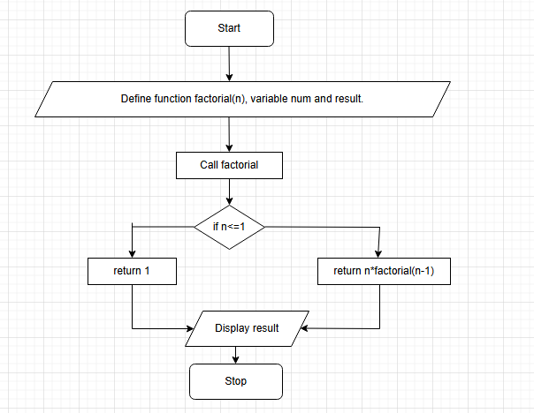
CODE:
#include <stdio.h>

int factorial(int n) {
if (n <= 1) {
return 1;
}
return n * factorial(n - 1);
}

int main() {
int num = 5;
int result = factorial(num);

printf("Factorial of %d is %d\n", num, result);
return 0;
}
PLATFORM: Linux

INPUT:
5
OUTPUT:
Factorial of 5 is 120.
CONCLUSION: Thus, we have successfully executed factorial of a number with and without recursion.

FAQs:
1. What is the purpose of calculating factorial in programming?
2. What is the difference between recursive and non-recursive (iterative) methods?

